

Inspirational activities from teachers

Belgium


Co-funded by the European Union
This document is part of the ABC4T project resources for educators, parents and early childhood education settings.

Country | Teacher | Goal of activity (in terms of antibias-education) | Description | Comments | pictures
Belgium | Elien Lavreys (De Luchtballon, Merksem) | Children learn that people can look similar or different and can talk about it in a respectful way | The personal doll Precious helps  the teacher find children  Personal doll ‘Precious’ has a dark skin and is introduced as the friend of the children who visits everyday.  During the morning welcoming routine, the teacher looks for ‘helper of the day’, making a riddle based on appearances:  - The child of the day likes to sing as much as Precious...  - The child of the day is wearing the same colour of pants as Precious...  - The child of the day has the same skin colour as Precious...  - The child of the day does not have dreadlocks as Precious does.  - ... | - The personal doll is chosen so it represents children of colour in the classroom. Make sure the personal doll is multifaceted and has talents, interests,... Afterwards, skin colour can be addressed, but should not be the only discussed characteristic of the doll.  - Make sure to also talk about other skin colours, including white. | 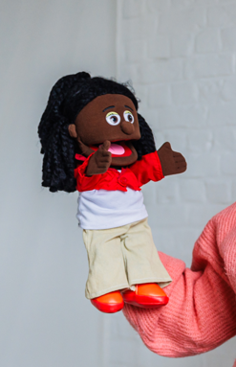
Belgium | Elien (De Luchtballon, Merksem) | Children learn about gender diversity in a positive and respectful way | My colour, my choice  Read aloud of the children’s book ‘Pink is for everybody’ (Ella Russell, 2022).  Ask the children reflective questions:  - Who likes the colour pink.  - Is pink for everyone? What do you think?  - Why can everyone like the colour pink?  - If you think this is only for girls, why is that?  After the discussion, children are invited to make a simple personal choice activity. They choose between different coloured cards or materials (including pink) and show or explain their choice in a non-judgemental way (e.g. “I like this colour because…”). The teacher emphasises that all choices are equally okay. | Make sure you have examples of boys/men that like pink to have contrastereotypes ready (for example show male football players wearing pink, such as Inter Miami or Palerma).  Make sure to prepare the conversation and dismantle stereotypical sayings by asking critical questions. Try not to persuade that pink is indeed for everyone, but rather invite children to broaden their perspectives by giving examples, asking critical questions and so on.
Belgium | Sofie (Groenendael) | Children learn that people can have different religions, and that they can also have things in common, and they learn to respect this | Discussing religious festivities  After reading a book about Eid al-Fitr, the children in the classroom got to talk about their experiences with Eid al-Fitr | - Beware of ‘generalizing’ the experiences related to Eid al-Fitr (or any religious festivity), and keep it nuanced.  - Stress communalities.  - Look for information yourself before organising an activity with children. | 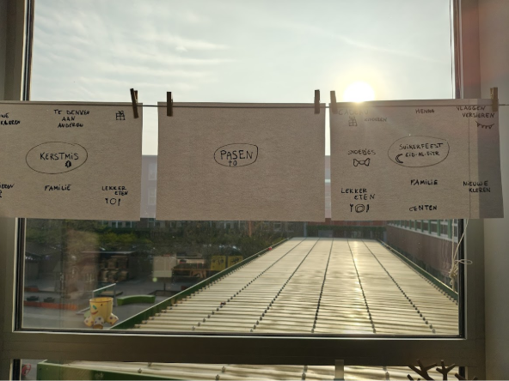
Belgium | Sofie Woestenborghs (De Schatkist) | Children learn that they can make friends with others even if they speak a different language, by using simple words, gestures and non-verbal communication.  Children develop a respectful attitude towards multilingualism. | How to make friends even if you speak a different language?  he teacher introduces Gaston the shrimp (Gaston is link with the children’s book Je bent al alles (Hanne Luyten & Noëmi Willeme), a book about a lonely character who learns that being yourself and saying hello is enough to make friends). Gaston sends a video message to the children: he has met a new friend who does not speak the same language.  Gaston shows short clips of children (or puppets) trying to communicate using gestures, facial expressions and simple words like “hello”, “come play”, “friend”.  The teacher asks the children:  - How do you think Gaston can make friends if he cannot understand the other child’s language?  - What can you do if you don’t know the words?  - Can you still play together? How?  The children brainstorm simple ‘friend-making strategie’ together (link with prior knowledge of brainstorming):  - waving  - smiling  - pointing  - showing toys  - saying “hello” in different languages  - inviting someone to play by gesture  In small groups (2–3 children), the children act out short situations:  - A new child arrives in the classroom and speaks a different language.  - How do you greet them?  - How do you invite them to play?  Afterwards, the groups share their ‘friend-making moment’ with the class or record a short video message for Gaston using the tablet. | - Focus on non-verbal communication as a real and valid way of connecting with others, not as a ‘second option’.  - Support children who are less verbal by giving them roles such as demonstrating gestures or holding materialsand accept all (‘imperfect’) language expressions.  - Encourage children to use their home languages if they want to greet or invite someone (e.g. saying “hello” or “come play” in their own language).  - A (known) persona doll can be used instead of starting from the described children’s book.

