

Inspirational activities from teachers

Norway


Co-funded by the European Union
This document is part of the ABC4T project resources for educators, parents and early childhood education settings.

Country | Teacher | Goal of activity (in terms of antibias-education) | Description | Comments | pictures
Norway |  | Children learn that in nature everyone can explore and play in different ways, and that they can include others respectfully | Nature as an inclusive space for interaction and belonging  Nature is used as a shared space for exploration, play and interaction among children. Being in nature offers opportunities for curiosity, wonder and discovery, where children can engage with the environment in their own way and at their own pace.  Children are encouraged to explore natural materials, spaces and elements freely. They can observe, collect, build, move, or simply watch, depending on their interests and comfort level. The open-ended character of nature supports different ways of participation and expression.  Play in nature is spontaneous and creative, allowing children to invent games, collaborate with others, or explore individually. There are no fixed rules or expected outcomes, which creates space for diverse forms of engagement.  Nature also offers opportunities for community building. Children can engage in shared exploration, cooperate in small groups, and develop positive relationships through play and discovery. | The teacher ensures that all children are included in play and exploration, with attention to children who are less visible or less active. They support different ways of participating and value observing, joining, or leading as equally valid.  The teacher models inclusive invitations such as “You can join in your own way” and encourages respectful interaction between children.  They observe group dynamics and intervene when needed to prevent exclusion or domination, helping to balance participation.  During play, the teacher uses short guiding questions like “Who is not involved yet?” and “How can we include them?” to support awareness of inclusion.  The teacher avoids directing play towards one correct way of interacting with nature and instead supports a variety of ways to explore, play and connect. | 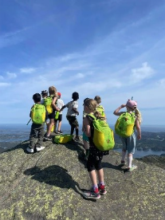  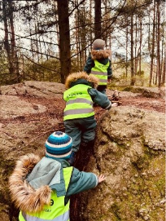
Norway |  | Children learn that play can be fair when everyone has access to enough materials, space and opportunities to participate. | Children explore a rich variety of open-ended materials such as pipes, planks, sand, cardboard boxes, paper, blocks, ropes, sticks, fabric and other loose parts.  The teacher first creates a situation where materials are introduced gradually or in limited amounts. Children are invited to start playing, while the teacher observes how materials are used and shared.  During play, the teacher briefly introduces an ‘extra challenge’ situation, for example:  - some children receive more materials than others  - some materials are placed further away  - some spaces are more crowded than others  This is followed by a guided conversation and continuation of play, focusing on fairness and inclusion.  Children are then invited to reorganise the play together:  - How can we make sure everyone can play?  - What do we need so nobody is left out?  - How can we share materials or space?  After this, children continue free play with the open-ended materials, now with a focus on fair access, sharing and cooperation. | The teacher intentionally uses the play situation to make children aware of fairness in access to materials and space.  They guide children away from competition towards cooperation and shared problem-solving.  The teacher supports reflection on inclusion by asking simple questions about fairness, access and sharing, without blaming or moralising.  They ensure that all children ultimately have access to materials and space, and help the group find inclusive solutions together.  The teacher values different strategies children use to make play fair and accessible for everyone.

