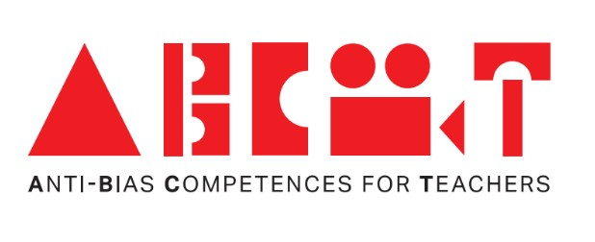

Inspirational activities from teachers

Poland


Co-funded by the European Union
This document is part of the ABC4T project resources for educators, parents and early childhood education settings
Country | Teacher | Goal of activity (in terms of antibias-education) | Description | Comments | Pictures
Poland | Oleksandra Ivanova-Komarshchuk | Children learn that people of any gender can have different interests, feelings and talents | ‘Gender-Box’-activity  Place the children into smaller groups (girls, boys or mixed-gender). Give each group a large sheet of paper divided into two parts, with an image of a girl drawn on one part and an image of a boy on the other, and lots of cutouts of pictures representing a wide range of activities that children may carry out and objects they can play with. Ask each group to create a “Boys’ & Girls’ Things” poster by placing items they think are associated with each gender next to the boy and girl figures. Afterward, discuss the posters with the children and confront stereotypes with real-life examples. For instance, you may refer to individuals known by the children who perform non-gender-stereotypical roles, women soccer players or Scots’ traditional clothing. | The division of children into separate groups of girls and boys may trigger stereotypical thinking, especially concerning the opposite gender. While this creates more opportunities to challenge rigidly prescribed gender roles, be especially attentive to gender-related stereotypes that may emerge in this context. | 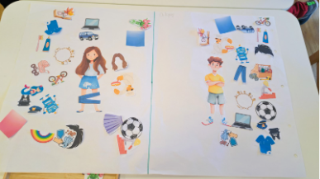
Poland | Oleksandra Ivanova-Komarshchuk- | Children learn to notice that people can be similar and different, and they learn to be open and respectful towards cultural diversity | Around the World with a Water Drop – Finding New Friends  Using a large map of the world, tell the children a story about a water drop that travels around the world, exploring different natural environments, animals and cultures. One day, the drop sets out to search for a new friend. Show the group photos of children from different parts of the world and invite them to discuss similarities and differences. Next, each child chooses a “new friend” from another country and creates an outfit and accessories for their character during an art activity. | When selecting photos of children, make sure to include images that reflect diversity within different parts of the world and avoid those that depict stereotypical images of people from different locations. If you decide to include photos of individuals in traditional clothing, make it clear to the children that this is not how they usually dress.
Poland | Aleksandra Suliga | Children learn that people can do the same activities in different ways and that everyone can take part when we support each other in respectful and inclusive ways. | How differently can we perceive the world?  The teacher reads the book “We’re All Different, Aren’t We?” by Tracey Turner and Asa Gilland.  Afterwards, the children take part in a series of playful activities in pairs. The activities are framed around exploring different ways of doing things.  The teacher introduces the activity by saying: “This is a game where we try different ways of doing things. Everyone can join in in their own way.”  One activity focuses on movement and guiding. One child is blindfolded while the other guides them safely through a simple obstacle course. Afterwards, they switch roles. The focus is on trust, communication and supporting each other.  Another activity focuses on communication. One child receives a short message, either spoken or shown, and communicates it using gestures so their partner can guess the meaning.  A third activity focuses on cooperation. Children work together to pass objects using elbows or other alternative ways, focusing on finding solutions together rather than on difficulty or performance.  After each activity, the teacher leads a short reflection by asking questions such as what helped them succeed, how they supported each other, and what other ways there could be to complete the task. | The teacher emphasises that there are many different ways to participate and succeed in activities. The focus remains on cooperation, support and inclusion rather than limitation or difficulty.  The teacher models respectful and supportive language such as asking if someone needs help, checking what support is useful, and encouraging children to try different ways instead of focusing on one “correct” way.  Reflection is guided towards inclusion and collaboration, highlighting what enables participation and valuing every child’s contribution.

